**Air Quality Monitoring**

Objectives:

The objective of air quality monitoring is to assess and track the quality of the air in a specific location or region to:

Protect Public Health: One of the primary goals of air quality monitoring is to safeguard public health. Monitoring helps identify and quantify the presence of pollutants and harmful substances in the air that can have adverse effects on human health. This information is crucial for implementing measures to reduce exposure to these pollutants.

Environmental Protection: Monitoring air quality is essential for protecting the environment, including ecosystems, vegetation, and wildlife. Poor air quality can lead to acid rain, damage to crops and forests, and harm to aquatic ecosystems.

Regulatory Compliance: Many countries and regions have established air quality standards and regulations to limit the concentrations of specific pollutants in the air. Air quality monitoring is used to ensure compliance with these standards and to enforce regulations, such as emissions control and permit requirements for industrial facilities.

Pollution Source Identification: Air quality monitoring helps identify and locate the sources of pollution. This information is critical for addressing and mitigating pollution, whether it's from industrial facilities, transportation, agriculture, or other sources.

Early Warning Systems: Monitoring air quality allows for the development of early warning systems that can alert the public and relevant authorities when pollution levels become hazardous. This is especially important for addressing air quality events like smog, wildfires, and industrial accidents.

Research and Data Analysis: The data collected from air quality monitoring is used for scientific research to understand the patterns of air pollution, its causes, and its effects on health and the environment. Researchers use this data to develop strategies to reduce pollution and mitigate its impacts.

Public Awareness and Education: Monitoring results are often made available to the public, raising awareness about the state of air quality and its health implications. This information can empower individuals to take actions to protect their health and the environment.

Policy and Decision-Making: Air quality monitoring data informs policymaking at various levels of government. Decision-makers use this information to develop and implement air quality management plans, regulations, and strategies for reducing pollution.

Assessment of Trends and Progress: Regular monitoring helps track changes in air quality over time. It allows for the assessment of the effectiveness of pollution control measures and the identification of emerging air quality issues.

Platform Development:

Tinkercad is an online platform for 3D design and electronics, and it is often used for educational purposes and prototyping projects. While Tinkercad primarily focuses on 3D modeling and electronics simulation, you can use it to create virtual prototypes and simulations for an air quality monitoring system. Here are some steps you can follow for the development of an air quality monitoring system using Tinkercad:

**Design Your Air Quality Monitoring System:**

Start by designing the components of your air quality monitoring system. This may include sensors for measuring various air quality parameters such as particulate matter (PM), carbon dioxide (CO2), carbon monoxide (CO), ozone (O3), and more.

Create a housing or casing for your monitoring system that will protect the sensors and other components.

**Electronic Simulation:**

Use Tinkercad's electronic design features to simulate the connections and interactions between the sensors and a microcontroller (e.g., Arduino).

Simulate the wiring and connections between the sensors, microcontroller, and any other electronic components like displays or communication modules.

**Programming and Code Simulation:**

Write the code for your microcontroller to read data from the sensors, process it, and potentially display the air quality information.

Tinkercad's platform allows you to write and simulate code for Arduino-based projects.

Run simulations to test your air quality monitoring system in Tinkercad. Adjust the design and code as needed to improve accuracy and functionality.

// include the library code:

#include <LiquidCrystal.h>

// initialize the library with the numbers of the interface pins

LiquidCrystal lcd(12, 11, 5, 4, 3, 2);

int pin8 = 8;

int analogPin = A0;

int sensorValue = 0; // store the value read

void setup() {

pinMode(analogPin, INPUT);

pinMode(pin8, OUTPUT);

// set up the LCD's number of columns and rows:

lcd.begin(16, 2);

// Print a message to the LCD.

lcd.print("What is the air ");

lcd.print("quality today?");

Serial.begin(9600);

lcd.display();

}

void loop() {

delay(100);

sensorValue = analogRead(analogPin); // read the input pin

Serial.print("Air Quality in PPM = ");

Serial.println(sensorValue); // debug value

lcd.clear();

lcd.setCursor(0,0);

lcd.print ("Air Quality: ");

lcd.print (sensorValue);

if (sensorValue<=500)

{

Serial.print("Fresh Air ");

Serial.print ("\r\n");

lcd.setCursor(0,1);

lcd.print("Fresh Air");

}

else if( sensorValue>=500 && sensorValue<=650 )

{

Serial.print("Poor Air");

Serial.print ("\r\n");

lcd.setCursor(0,1);

lcd.print("Poor Air");

}

else if (sensorValue>=650 )

{

Serial.print("Very Poor Air");

Serial.print ("\r\n");

lcd.setCursor(0,1);

lcd.print("Very Poor Air");

}

if (sensorValue >650) {

// Activate digital output

digitalWrite(pin8, HIGH);

}

else {

// Deactivate digital output

digitalWrite(pin8, LOW);

}

}

**Visualization and Data Logging:**

Implement a way to visualize the air quality data, whether through a simulated display or by sending data to a cloud platform for storage and visualization.

**Power Supply:**

Consider how your system will be powered. Include any power source, such as batteries or a simulated power supply.

**Connectivity:**

If your system communicates with external devices or the internet, simulate the connectivity and data transmission in Tinkercad.

**Documentation and Educational Materials:**

If your project is for educational purposes, create documentation or tutorials explaining how the air quality monitoring system works. Tinkercad can also help in creating educational materials.

**Real-World Implementation:**

Once you are satisfied with your Tinkercad simulation, you can proceed to implement the system in the real world using physical components.

**A real-time air quality monitoring system can play a significant role in raising public awareness about air quality and its health impacts in several ways**:

Accessible Information: These systems provide up-to-the-minute data on air quality, making information readily available to the public. This data is often presented through user-friendly interfaces, such as websites and mobile apps, making it easy for people to access and understand.

Transparency: By providing transparent and real-time information, these systems empower individuals to make informed decisions about their daily activities, like outdoor exercise, commuting, or even keeping windows closed during poor air quality days.

Alerts and Warnings: Real-time monitoring systems can issue alerts and warnings when air quality deteriorates significantly. These alerts can be delivered via mobile apps, text messages, or email, which help individuals take immediate action to protect their health.

Educational Tools: These systems often include educational resources, such as explanations of air quality indices, health recommendations, and the effects of various pollutants. This information can increase public knowledge about air quality issues and their health implications.

Public Engagement: Real-time monitoring systems encourage public engagement and participation in addressing air quality concerns. People can report air quality issues, share information, and collaborate on local initiatives to improve air quality.

Community Outreach: Local authorities and environmental organizations can use the data from these systems to conduct outreach programs, workshops, and seminars to educate communities about the importance of clean air and how to reduce their contribution to air pollution.

Policy Advocacy: Real-time air quality data can be used to advocate for stricter environmental regulations and policies. Citizens armed with accurate data are more likely to support or demand changes that can lead to cleaner air and better public health.

Behavior Change: As individuals become more aware of the health impacts of poor air quality, they may adopt healthier behaviors. This can include reducing vehicle emissions, using public transportation, and supporting cleaner energy sources.

Health Promotion: The information provided by real-time monitoring can be integrated into public health campaigns. Health authorities can promote awareness of respiratory problems, allergies, and other conditions related to air quality, encouraging individuals to seek appropriate healthcare when needed.

Research and Development: Data collected by these monitoring systems can contribute to ongoing research on air quality and its health effects, leading to a better understanding of the issue and more effective interventions.

Project Implementation:

To design a Air Quality Monitoring using Tinkercad software and create a platform that display real time air quality data .And design the platform to receive and display air quality data send by the IoT devices.

**RECUIREMENTS:**

System with Tinkercad software

**OPERATION:**

* Create own account in Tinkercad Software
* Create a new project
* Select Components such

1. Potentiometer
2. Arduino Uno
3. Gas sensor
4. Piezo
5. LCD display
6. Bread board
7. Resistors(10k ohm,10k ohm,1k ohm)

* Connect all the components as well as given circuit diagram Fig.1.
* Write a code to given circuit diagram

// include the library code:

#include <LiquidCrystal.h>

// initialize the library with the numbers of the interface pins

LiquidCrystal lcd(12, 11, 5, 4, 3, 2);

int pin8 = 8;

int analogPin = A0;

int sensorValue = 0; // store the value read

void setup() {

pinMode(analogPin, INPUT);

pinMode(pin8, OUTPUT);

// set up the LCD's number of columns and rows:

lcd.begin(16, 2);

// Print a message to the LCD.

lcd.print("What is the air ");

lcd.print("quality today?");

Serial.begin(9600);

lcd.display();

}

void loop() {

delay(100);

sensorValue = analogRead(analogPin); // read the input pin

Serial.print("Air Quality in PPM = ");

Serial.println(sensorValue); // debug value

lcd.clear();

lcd.setCursor(0,0);

lcd.print ("Air Quality: ");

lcd.print (sensorValue);

if (sensorValue<=500)

{

Serial.print("Fresh Air ");

Serial.print ("\r\n");

lcd.setCursor(0,1);

lcd.print("Fresh Air");

}

else if( sensorValue>=500 && sensorValue<=650 )

{

Serial.print("Poor Air");

Serial.print ("\r\n");

lcd.setCursor(0,1);

lcd.print("Poor Air");

}

else if (sensorValue>=650 )

{

Serial.print("Very Poor Air");

Serial.print ("\r\n");

lcd.setCursor(0,1);

lcd.print("Very Poor Air");

}

if (sensorValue >650) {

// Activate digital output

digitalWrite(pin8, HIGH);

}

else {

// Deactivate digital output

digitalWrite(pin8, LOW);

}

}

* Start simulation
* And Analyse the Air quality by using LCD display

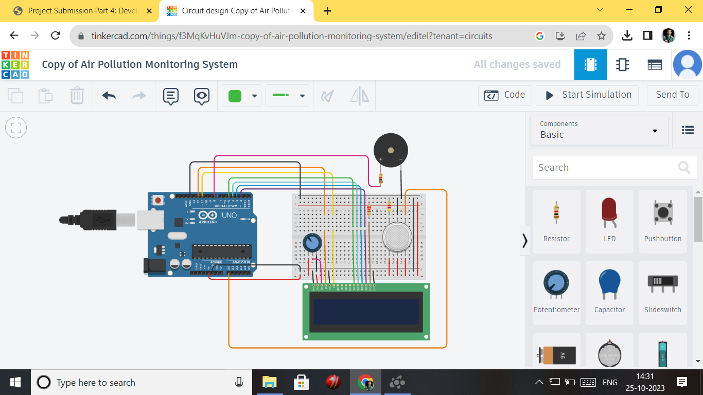

Fig.1.Cicuit diagram

* The above circuit diagram fig.1. illustrate ,Circuit diagram of Air quality monitoring.When air is pure the LCD does not display.

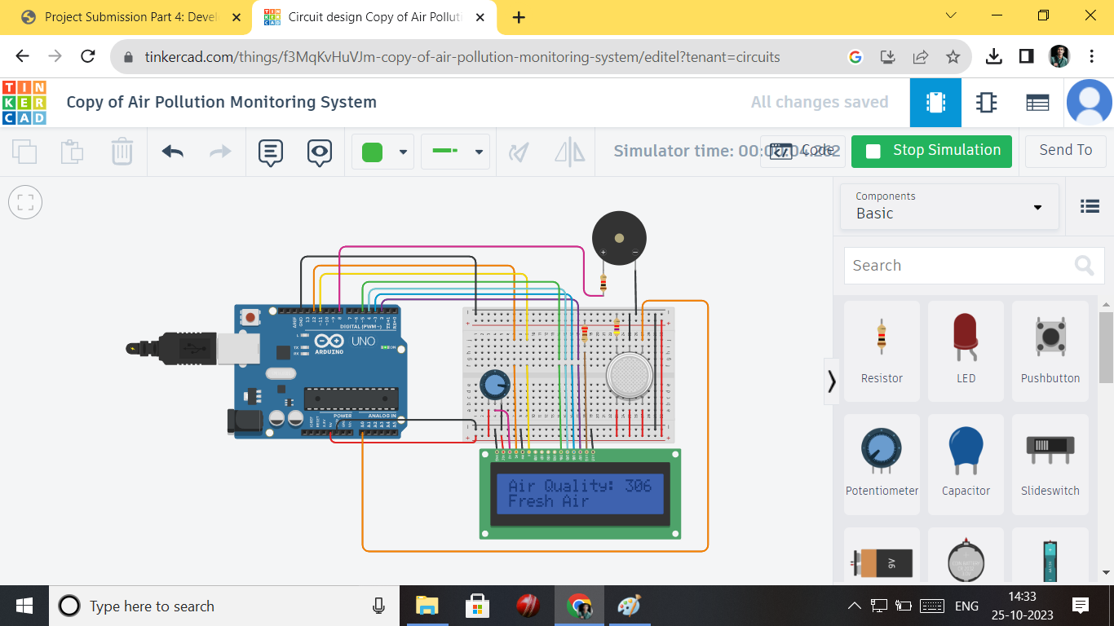

Fig.2.Air was polluted less

The above circuit Fig.2. is illustrate,circuit diagram of air quality monitoring it is display blue colour letters.If it is blue colour letters the air was less amount of polluted.

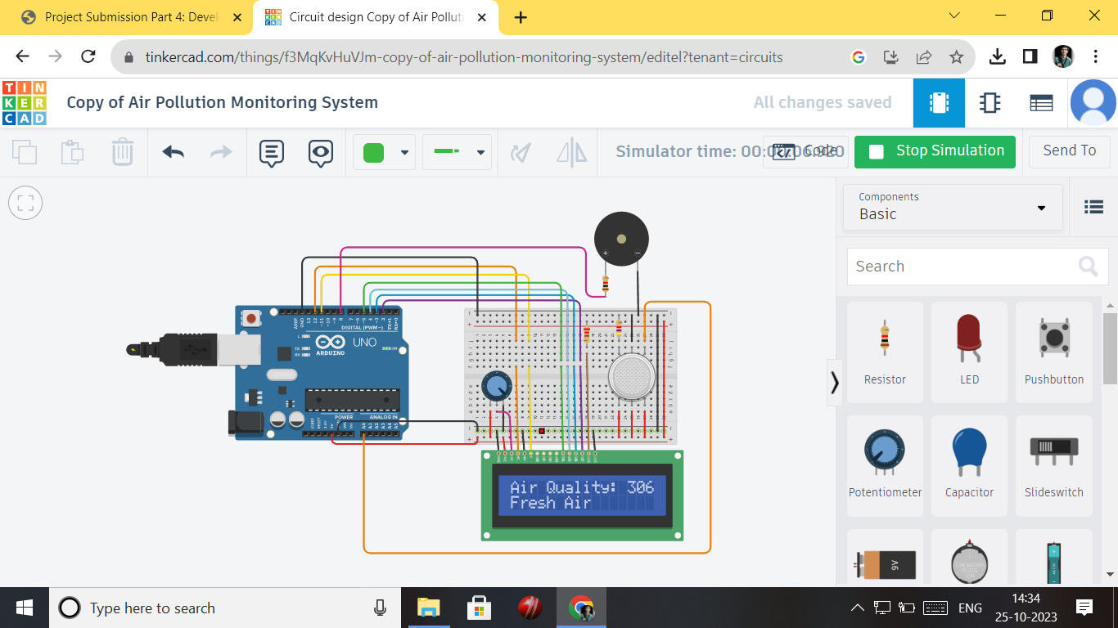

Fig.3.Polluted Air Display

The above circuit diagram Fig.3. is illustrate , The air was more amount of polluted. When then letters are display in white colour the air was polluted more .

LAB SETUP

